System Models

Use Case Diagram

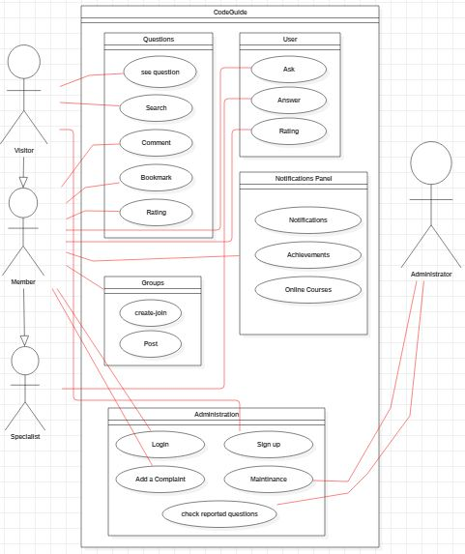

This diagram shows how different users can access the website

Sequence Diagrams

1

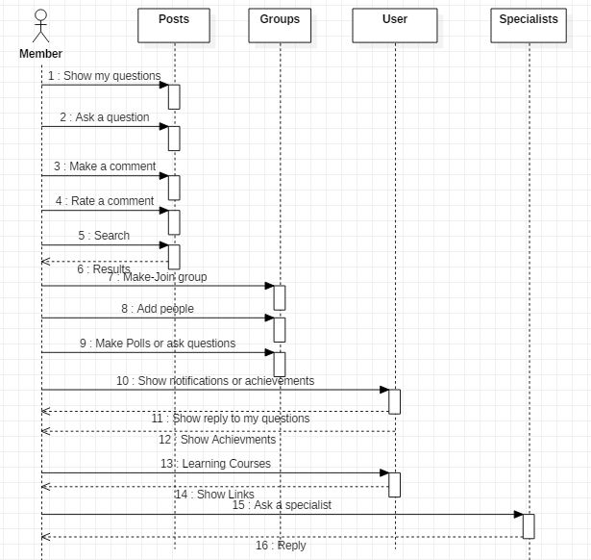

This diagram shows functions that the member can make on the website